**BE 2022-23**

**LP III Lab assignment**

**Group B - Machine learning**

1. **Assignment 1**

Predict the price of the Uber ride from a given pickup point to the agreed drop-off location.

Perform following tasks:

1. Pre-process the dataset.

2. Identify outliers.

3. Check the correlation.

4. Implement linear regression and random forest regression models.

5. Evaluate the models and compare their respective scores like R2, RMSE, etc.

Dataset link: https://www.kaggle.com/datasets/yasserh/uber-fares-dataset

**Date of assignment : 17/08/2022 Due date of submission:27/08/2022**

1. **Assignment 2**

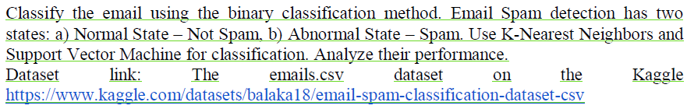

1. **Assignment 3**

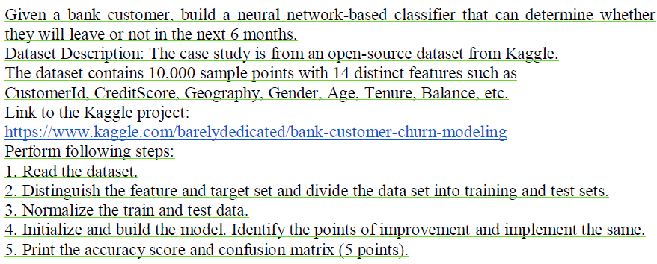

1. Anyone assignment out of following

Implement Gradient Descent Algorithm to find the local minima of a function.

For example, find the local minima of the function y=(x+3)² starting from the point x=2.

OR

Implement K-Nearest Neighbors algorithm on diabetes.csv dataset. Compute confusion matrix,

accuracy, error rate, precision and recall on the given dataset.

Dataset link : <https://www.kaggle.com/datasets/abdallamahgoub/diabetes>

OR

Implement K-Means clustering/ hierarchical clustering on sales_data_sample.csv dataset. Determine the number of clusters using the elbow method.

Dataset link : https://www.kaggle.com/datasets/kyanyoga/sample-sales-data

1. Mini project

Use the following dataset to analyze ups and downs in the market and predict future stock price returns based on Indian Market data from 2000 to 2020.

Dataset Link: https://www.kaggle.com/datasets/sagara9595/stock-data

OR

Build a machine learning model that predicts the type of people who survived the Titanic shipwreck using passenger data (i.e. name, age, gender, socio-economic class, etc.).

Dataset Link: https://www.kaggle.com/competitions/titanic/data